**Clover 4 Renewable Energy Solutions**

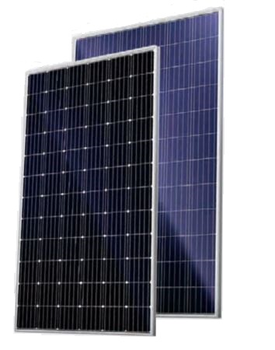**LNSF**



ISO 9001:2015&ISO14001

Management systems



Standard quality



0-5W positive power sorting



Stable performance under weak light



Wind load up to 3800Pa

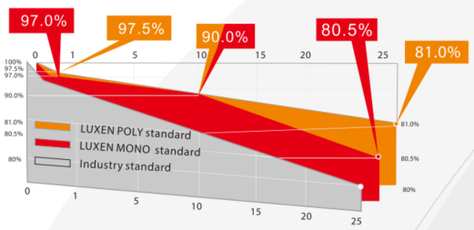 Snow load up to 5400Pa



Salt Mist and ammonia corrosion

Tests Passed



10 Years Product warranty

25 years **Linear** power warranty

 **Insured by PICC**

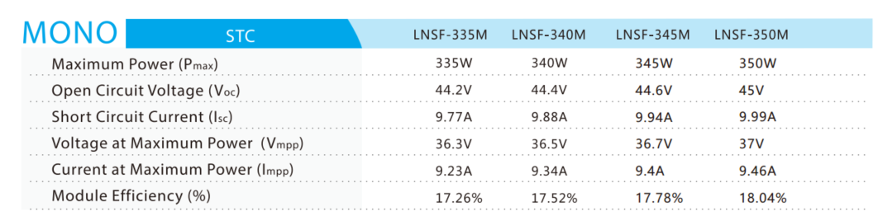

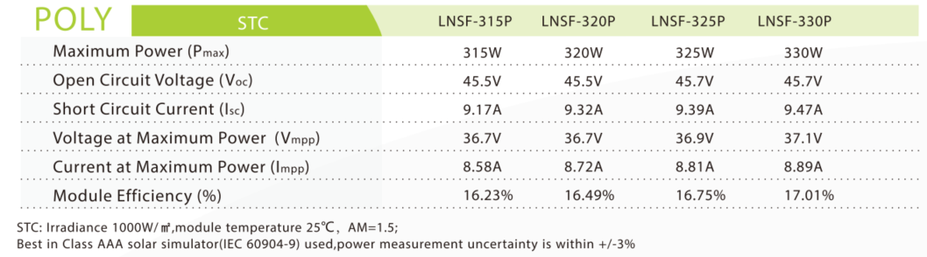

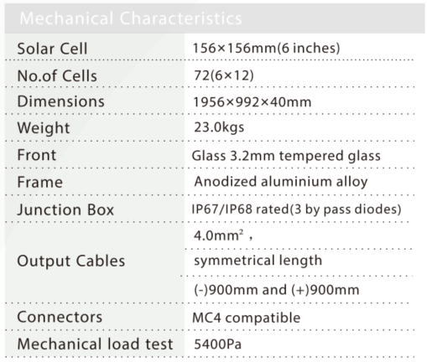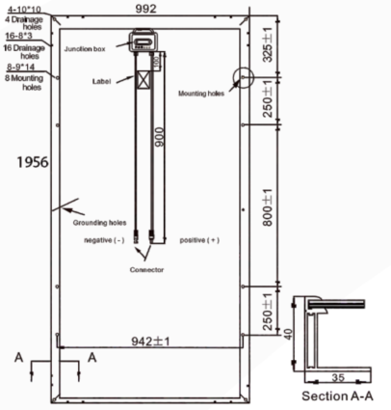

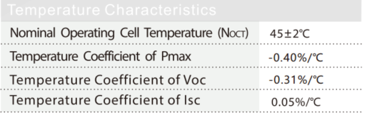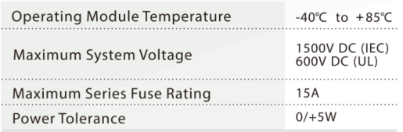

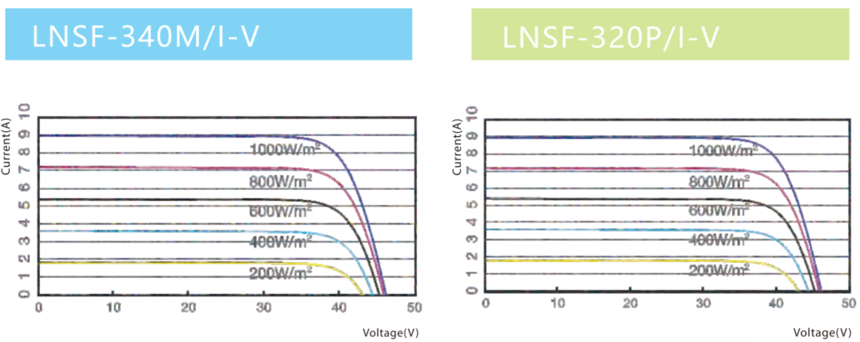

LNSF is a series of Premium quality modules with a wide range of power ratings, that makes this range suitable for all types of projects and systems, from small scale private roof top systems to large scale solar power farms.

